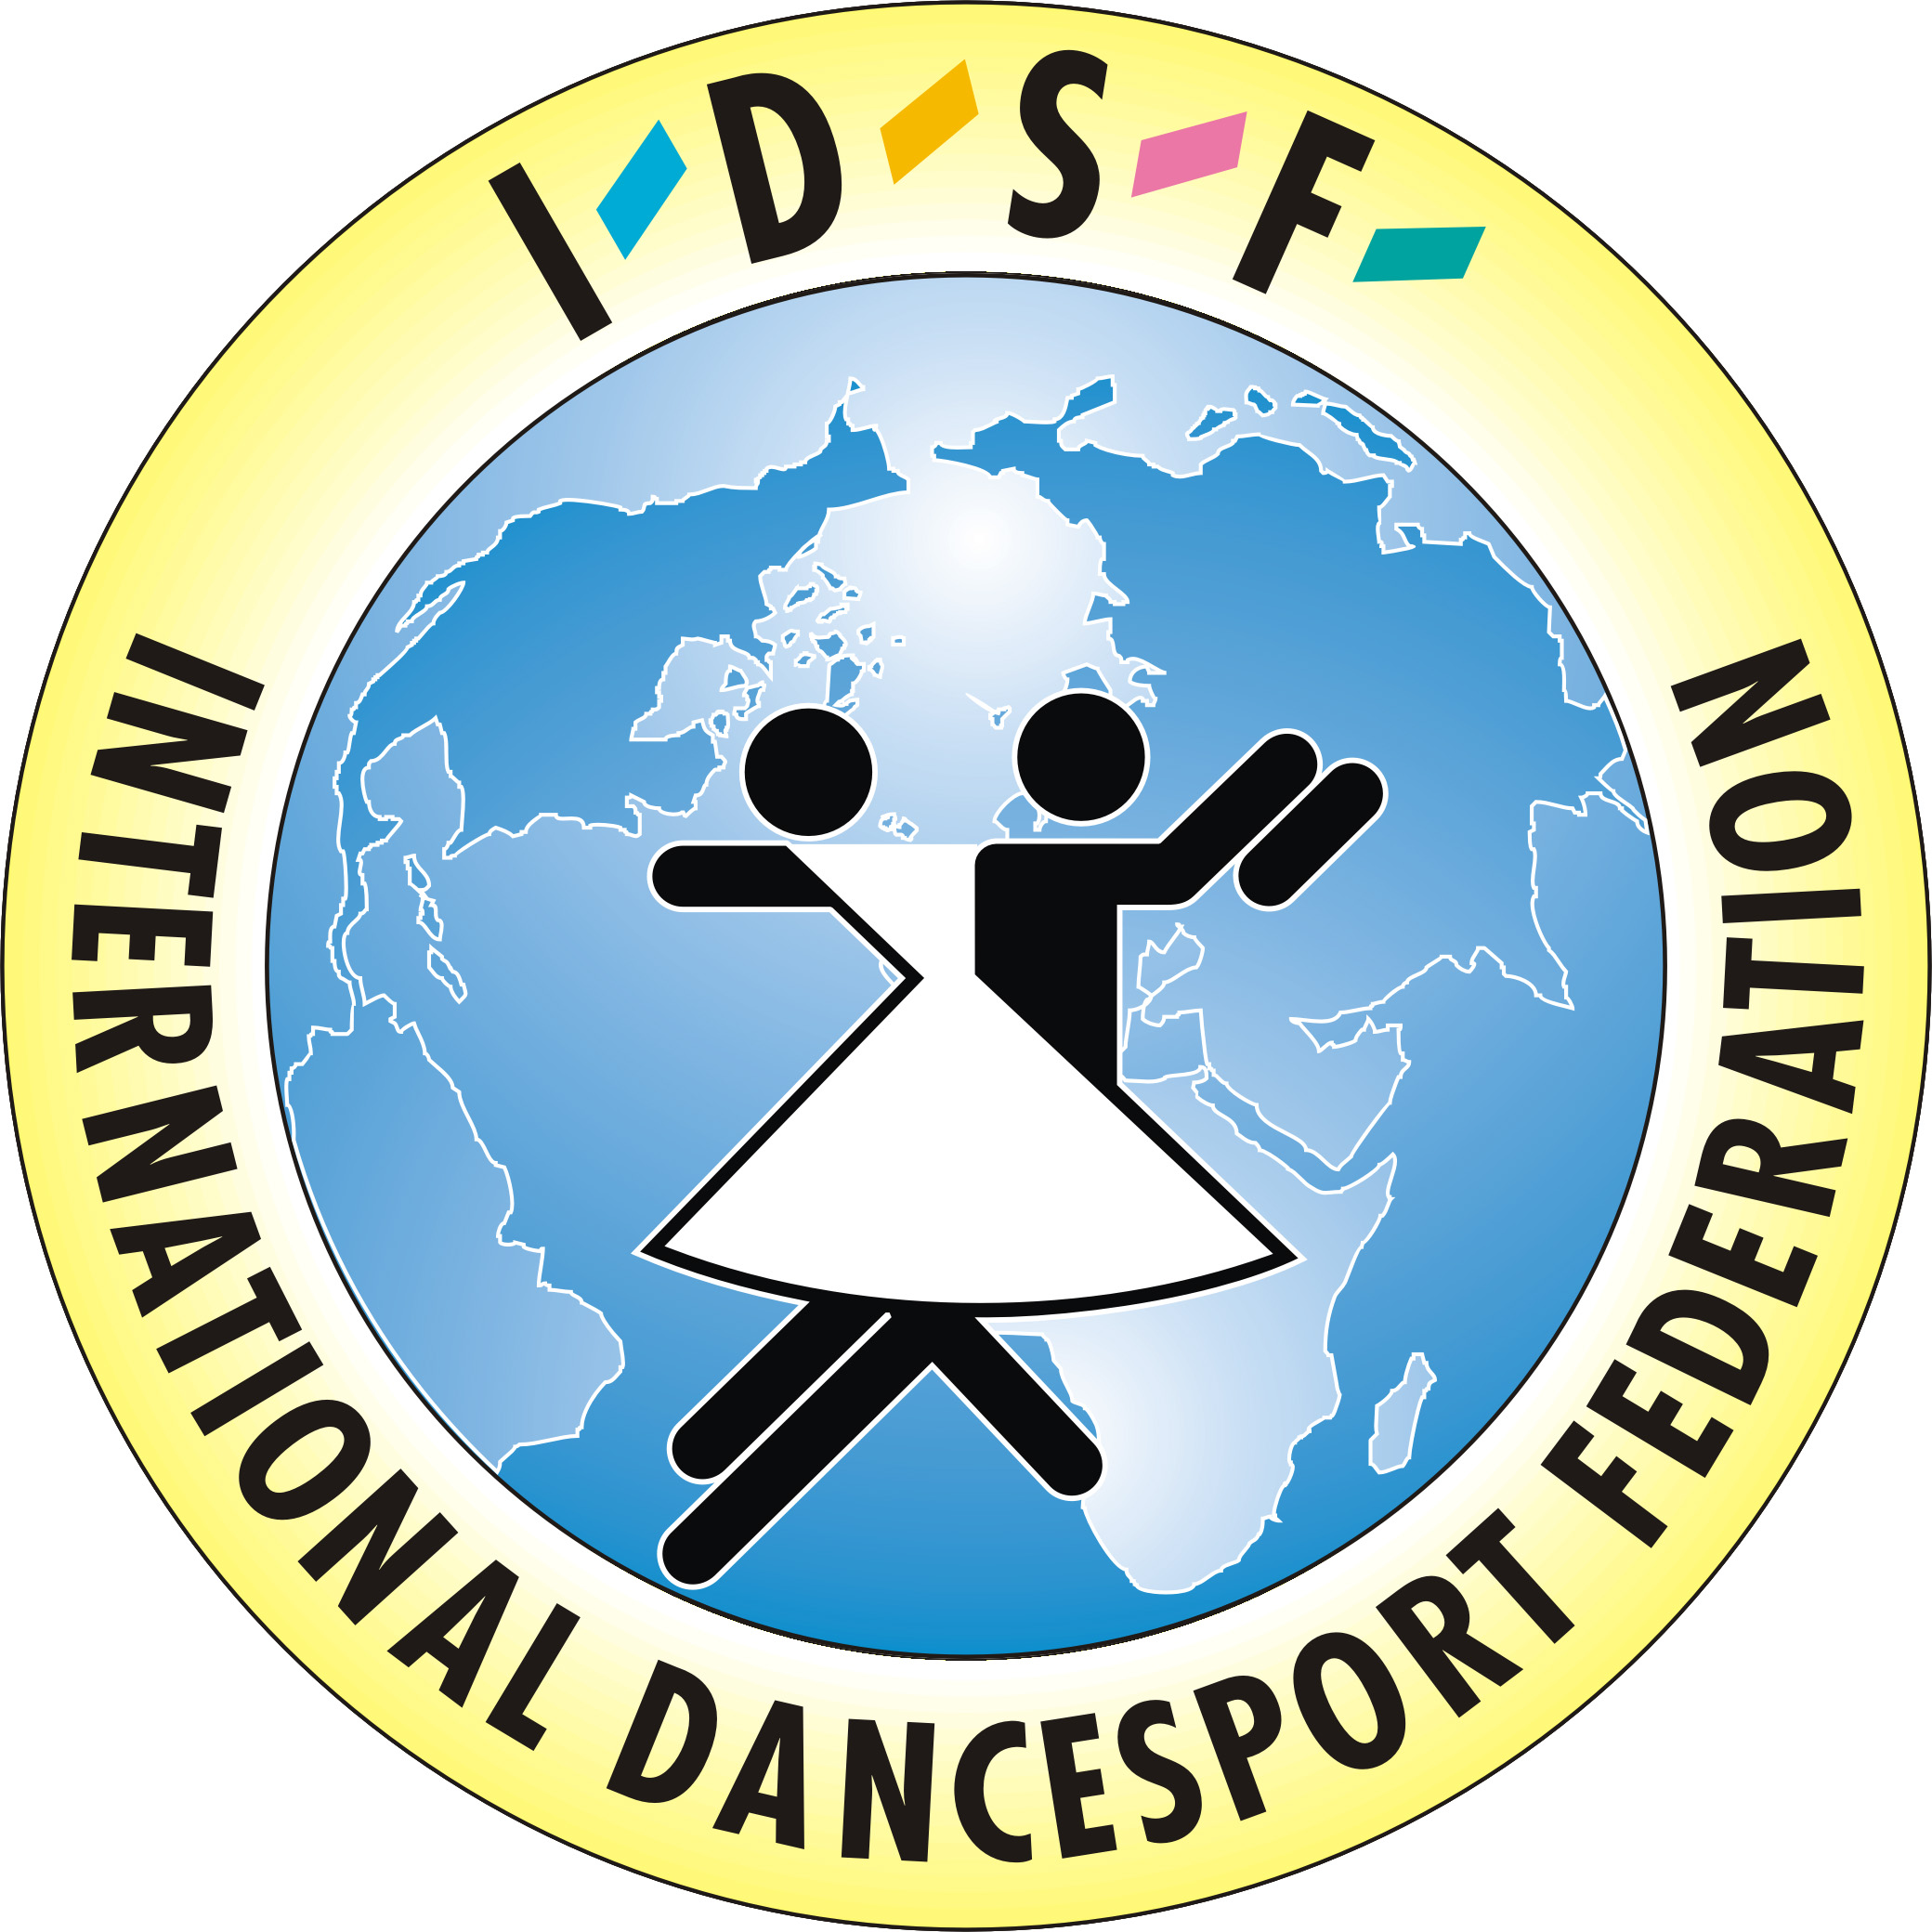
International Dance Sport Federation “Alfa-Tsisaphers Dance Sport Academy”

To all IDSF and IPDSC member federations

Dear Ladies and Gentlemen,

To the following competition we invite very cordially couples of your Nation
The 10th International Dance Sport Championships “ASHDOD-2007”.

PLACE: "Hakiria"Sport Hall, City Quarter, 90 Haatzmaut Street, Ashdod, Israel.
DATE Saturday December 8th , and Sunday December 9th 2007.
CATEGORY: IPDSC EUROPEAN PROFESSIONAL LATIN CHAMPIONSHIP 2007 8.12.07
IDSF OPEN STANDARD - 8.12.07
IDSF INTERNATIONAL OPEN LATIN- 9.12.07
Open competition for Juniors-I, Juniors-II, Youth - STANDARD and LATIN
CONDITIONS: For IPDSC EC couples Hotel (up to two nights) will be paid by the organizer
RULES: According the IPDSC and IDSF Competitions Rules.
DRESS: IPDSC and IDSF Competitions Rules must be applied
ENTRY FEE: EU 20 per couple for one program.
PRIZE MONEY EU 8500 IN TOTAL
ACCOMODATION: Official Hotel of the “Ashdod-2007” Championship is “MERCURE” Bat-Yam,
all rooms are suite, reservation through the organizer by FAX +972 88 644374, or
by E-mail: odikadze@zahav.net.il
TRANSPORT: Organizers will provide all the couples with transport from the Airport to the Hotel and
back , and also from the Hotel to the competition’s venue and back.
JUDGES: Panel of Top International adjudicators from eleven different Nationalities
ORGANIZERS: IPDSC, IDSF, Israel Dance Sport Association,
Tsisaphers Dance Sport Academy,
Municipality Of Ashdod,
Boris and Rozana Odikadze
VISA: If you need the visa to Israel, please send to organizer the scanned copy of your, address
and name of the suitable town in your country with Israeli consulate to get VISA.
In case of any questions, don’t hesitate to contact us
ASHDOD INTERNATIONAL DANCE SPORT CHAMPIONSHIPS

BORIS ODIKADZE

Chairman of Organizing Committee
President of Israel Dance Sport Association
11 Yavniel Street, Ashdod 77641, Israel
Phone: 972 88 678027; Fax 972 88 644 374
Mobil 972 66 602 554; E-mail: odikadze@zahav.net.il,

